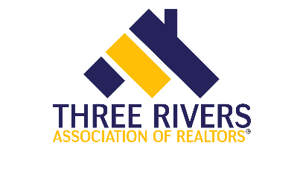

Core 1906 – IL Core
4 hour core credit
Course Date: Thursday April 12th |  |  |  |  |  |  |  |  | Time: 9am – 1pm
Presented by:  Three Rivers Association of REALTORS® |  |  |  |  |  |  |  |  | Course 564003753
Course Description:  This course will provide attendees with the knowledge and skills necessary to protect consumers, enhance the professionalism of the real estate brokerage industry and prevent violations of the Real Estate Act. |  |  |  |  |  |  |  |  | Instructor: Annette Panzek
Course Location:
Zoom

Members: Included in Membership/No additional charge

Non Members: $35

REGISTRATION
If you require special accommodations due to a disability, please describe the accommodation(s) requested:
Name: |  |  |  |  |  |  |  | NRDS or  License #:
Business Address:
City/State |  |  |  |  |  |  |  |  | Zip:
Email: |  |  |  |  |  |  |  |  | Phone:
Payment type: |  |  | Check |  |  | Credit/Debit: Visa Mastercard Discover Amex
Account #: |  |  |  |  |  |  | Expires: |  |  |  |  |  |  | Security  Code:
Signature:
Make check payable to: |  |  |  |  | Three Rivers Association of Realtors
Submit registration to: |  |  |  |  | Molly Babyak
Email: |  | molly@trarealtors.net |  |  |  |  |  |  | Phone: |  |  |  | 815-744-4520
Postal Mail: |  |  |  | 303 Springfield Ave, Joliet, IL 60404

