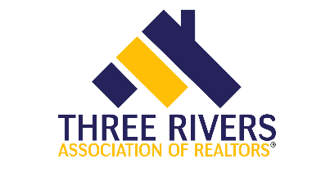

RB 746- Elements of a Contract
3 hour elective
Course Date: Thursday, April 14th |  |  |  |  |  |  |  |  | Time: 9:00am – 12:00pm
Presented by:  Three Rivers Association of REALTORS® |  |  |  |  |  |  |  |  | Course 564003122
Course Description:  Although the actual contracts and riders may change from one area to another, the concepts and elements involved in sound contract writing do not. This course is designed to cover the elements inherent in all real estate contracts and how the agents’ knowledge impacts their clients, as well as explore the most recent concerns regarding contract preparation. |  |  |  |  |  |  |  |  | Instructor: Lynn Madison
Course Location:
Three Rivers Assn. of Realtors
303 Springfield Ave.
Joliet, IL 60404

Members: FREE
Non Members: $35

REGISTRATION
If you require special accommodations due to a disability, please describe the accommodation(s) requested:
Name: |  |  |  |  |  |  |  | NRDS or  License #:
Business Address:
City/State |  |  |  |  |  |  |  |  | Zip:
Email: |  |  |  |  |  |  |  |  | Phone:
Payment type: |  |  | Check |  |  | Credit/Debit: Visa Mastercard Discover Amex
Account #: |  |  |  |  |  |  | Expires: |  |  |  |  |  |  | Security  Code:
Signature:
Make check payable to: |  |  |  |  | Three Rivers Association of Realtors
Submit registration to: |  |  |  |  | Molly Babyak
Email: |  | molly@trarealtors.net |  |  |  |  |  |  | Phone: |  |  |  | 815-744-4520
Postal Mail: |  |  |  | 303 Springfield Ave, Joliet, IL 60404

